

##### VISVESVARAYA TECHNOLOGICAL UNIVERSITY

##### BELAGAVI-590 018, KARNATAKA.

AN INTERNSHIP REPORT ON

“Working on Full Stack Web development with Java, Mysql”

A Case Study - Hospital Management System

*Submitted in the partial fulfillment of the requirements for the award of Degree*

#### B.E. in Computer Science & Engineering

##### PROJECT ASSOCIATES

**Chetan Raju Attanagi 4BD22CS403**

**Saivarshith G R 4BD22CS411**

**Shivakumar V 4BD22CS413**

**Suhas S M 4BD22CS416**

**Syed Zubair 4BD22CS417**

**PROJECT GUIDE EXTERNAL GUIDE**

**Dr. Chetana Prakash Ph.D, Mr.Matheiyarashan.T**

Professor, Dept. of CS&E, Program manager,

B.I.E.T. Davangere Destination, Bengaluru

#### Department of Computer Science and Engineering, Bapuji Institute of Engineering & Technology, Davangere- 577004

**2022-23**

**Bapuji Institute of Engineering and Technology, Davangere - 577004**



#### Department of Computer Science and Engineering

CERTIFICATE

This is to certify that Chetan Raju Attanagi, Saivarshith G R, Shivakumar V, Suhas S M, Syed Zubair bearing USNs 4BD22CS403, 4BD22CS411, 4BD22CS413, 4BD22CS416, 4BD22CS417 respectively of Computer Science and Engineering department have satisfactorily submitted the Internship Project Report entitled “Full Stack Web Development with Hospital Management System” in the partial fulfillment of the requirements for the award of Degree of Bachelor of Engineering (B.E.) in Computer Science & Engineering, under the VTU during the academic year 2022-23.

**INTERNSHIP GUIDES**

Prof. Gangadharappa M.tech. Mr. Matheiyarashan T.

Internal Guide External Guide

|  |  |  |  |  |
| --- | --- | --- | --- | --- |
| **Dr. Arun Kumar G H Ph.D.** |  | **Dr. Nirmala C R Ph.D.** |  | **Dr. H B Aravind Ph.D.** |
| Internship Co-ordinator |  | Head of the Department |  | Principal |

**External Examination**

**Name of the Examiners Signature with Date**

1. **1.**
2. **2.**

**Bapuji Educational Association (Regd.)**

**Bapuji Institute of Engineering and Technology, Davangere-577004 Department of Computer Science and Engineering**

**Vision and Mission of the Department**

##### VISION

To be a center of excellence in imparting state-of-the-art technology in the field of Computer Science and Engineering education enabling the students to become professionally sound and ethically strong.

##### MISSION

|  |  |
| --- | --- |
| M1 | Adapting best teaching and learning techniques that cultivates Questioning and  Reasoning culture among the students. |
| M2 | Creating collaborative learning environment that ignites the critical thinking in  students and leading to the innovation. |
| M3 | Establishing Industry Institute relationship to bridge the skill gap and make them  industry ready and relevant. |
| M4 | Mentoring students to be socially responsible by inculcating ethical and moral values. |

###### PROGRAM EDUCATIONAL OBJECTIVES (PEOs)

The graduates will be able to

|  |  |
| --- | --- |
| PEO1 | To apply the skills acquired in the field of computer science and engineering in  solving the societal and industrial problems with technology intervention. |
| PEO2 | To continue their career in industry, academia and to pursue higher studies and  research |
| PEO3 | To become successful entrepreneurs, innovators and job creators to design and  develop software products and services to meet the societal, technical and business challenges |
| PEO4 | To work in diversified environment by acquiring leadership qualities with strong  Communication skills along with professional and ethical values |

**PROGRAM SPECIFIC OUTCOMES (PSOs)**

|  |  |
| --- | --- |
| PSO1 | Analyze and develop solutions for problems that are complex in nature but applying  the knowledge acquired from the core subjects of this program. |
| PSO2 | To develop secure, Scalable, Resilient and distributed applications for industry and  Societal requirements. |
| PSO3 | To learn and apply the concepts and construct of emerging technologies like  Artificial Intelligence, Machine learning, Deep learning, Big Data Analytics, IOT, Cloud Computing, etc for any real time problems. |

## ACKNOWLEDGMENT

Salutations to our beloved and highly esteemed institute, “**BAPUJI INSTITUTE OF ENGINEERING AND TECHNOLOGY**” for having well-qualified staff and labs furnished with the necessary equipment.

Foremost, we would like to express our sincere gratitude to **Mr. Matheiyarashan T**, Program manager, i sans technology, Bengaluru, for his guidance and knowledge sharing throughout this journey to carry out the internship project work successfully.

We express our sincere thanks to our guide **Dr. Nirmala C R,** who is also our respected

H.O.D of Department of Computer Science & Engineering for giving us constant encouragement, support and valuable guidance throughout the course of the project without whose stable guidance this project would not have been achieved.

We express wholehearted gratitude to our Internship Coordinator **Dr. Gangadharappa S**. We wish to acknowledge him, who made our task easy, by providing with his valuable help and encouragement.

We also express our whole hearted gratitude to our principal, **Dr. H B Aravind** for his moral support and encouragement.

We would like to extend our gratitude to all staff of **Department of Computer Science and Engineering** for the help and support rendered to us. We have been benefited a lot from the feedback, suggestions given by them.

**Chetan Raju Attanagi 4BD22CS403**

**Saivarshith G R 4BD22CS411**

**Shivakumar V 4BD22CS413**

**Suhas S M 4BD22CS416**

**Syed Zubair 4BD22CS417**

# ABSTRACT

Agile is a method of software development that aims to deliver functional software consistently through brief iterations. Hospital Management System project is implemented in terms of agile to deliver in sprints. Team has collected requirements and created product backlog. Sprint planning has been done by team, user stories delivered in sprints. Database size estimations and peak operations size has been identified. The Hospital Management System is a critical application used by educational institutions to manage their course schedules. The objective of this project is to improve the delivery speed, quality, and reliability of the Hospital Management System. Aim of our work is to implement Full Stack Web development practices for a Hospital Management System. The project involved the creation of a continuous integration and continuous deployment pipeline for the Hospital Management System. The pipeline included various stages such as code compilation, testing, packaging, and deployment. The pipeline was implemented using popular Web Development tools such as Eclips, VS code and Mysql. To ensure the quality of the Hospital Management System, several automated tests were integrated into the pipeline using VS code. These tests included unit tests, integration tests, and acceptance tests. The pipeline was also configured to trigger automatic builds and deployments whenever changes were made to the source code repository. The Web Development known for on-demand availability of computer system resource, Design , and . Web Development is been used to deploy the application in Various Business Fields. As a result of the implementation, The Hospital Management System achieved faster and more reliable releases, with reduced deployment time and increased productivity. The project demonstrated the benefits of Web Development practices in improving the software development and deployment processes.

#### CONTENTS

**TOPICS PAGE NO.**

**Chapter 1: Introduction 01-03**

* 1. About the Company
  2. Agile Methodology
  3. DevOps
  4. Fullstack with java
  5. Java Introduction

**Chapter 2: Tasks Performed 04-06**

* 1. Task Performed in Week 1 and 2
  2. Task Performed in Week 3 and 4

**Chapter 3: System Requirements 07**

* 1. Tools and Technologies Identified
     1. Hardware Requirements
     2. Software Requirements
     3. Tools Identified

**Chapter 4: System Design 08**

* 1. System Architecture
  2. Flow Diagram

**Chapter 5: Methodology 09-11**

* 1. Description of the Project Work
  2. Steps to be followed

**Chapter 6: Results and Discussion 12-14**

**Conclusion References**

## CHAPTER 1

### **INTRODUCTION**

###### About the Company/ Resource Person

Welcome to Destination Technologies, your premier destination for cutting-edge software training and professional development. Our mission is to equip individuals with the latest technologies and skills demanded by the employment market. With a focus on staying current and offering top-notch training, we provide a platform for new students and professionals to thrive in the IT industry.

Mr. Subramanya Raj brings over 5+ years of industry experience, leading engineering teams for Mresult Services Pvt Ltd. With an additional 9+ years of teaching experience in engineering software disciplence .  
  
Starting his career as a Technical Lead, Mr. Raj realized the importance of team influence and achieving results through others. Driven by his passion for teaching, he transitioned to become a leading academic voice, spending over ten and a half years training students in various software engineering disciplines.

###### Agile Methodology

Agile is an iterative approach of project management and software development that helps team members deliver significance to their clients more rapidly and stress-free. An agile team produces work in small, digestible increments as opposed to placing all of their eggs in one massive "big bang" launch. Due to the regular evaluation of needs, plans, and results, teams have a technique for responding quickly to change.

The Manifesto for Agile Software Development: The programmers describe a novel approach to creating software as well as 4 crucial characteristics they believe should take precedence over other factors. As they put it, agile software development teams should value:

* + - Individuals and interactions over processes and tools
    - Working software over comprehensive documentation
    - Customer collaboration over contract negotiation
    - Responding to change over following a plan

###### DevOps

A Specific team that works to design, create, and deliver secure software quickly is known as a DevOps team. With automation, teamwork, quick feedback, and iterative improvement, DevOps principles allow software development (dev) and operations (ops) teams to expedite deliveries.

Stemming from an Agile approach to software development, a DevOps process expands on the cross-functional approach of building and shipping applications in a faster and more iterative manner. In adopting a DevOps development process, one can make a decision to improve the flow and value delivery of their application by encouraging a more collaborative environment at all stages of the development cycle.

DevOps represents a change in mindset for IT culture. In building on top of Agile, lean practices, and systems theory, DevOps focuses on incremental development and rapid delivery of software. Success relies on the ability to create a culture of accountability, improved collaboration, empathy, and joint responsibility for business outcomes.

###### Fullstack with java

Full stack development is the practice of developing both the front-end and back-end of a web application. Java is a popular programming language for both front-end and back-end development.

Front-end development is the development of the user interface of a web application.

This includes the HTML,CSS, and JavaScript that make up the look and feel of the application.

Back-end development is the development of the server-side logic of a web application.

This includes the Java cod that processes user requests and generates responses.

There are many benefits to using Java for full stack development. Java is a powerful and

versatile language that can be used to develop a wide range of applications. It is also a popular

language, so there is a large community of developers who can provide support and assistance.

If you are interested in becoming a full stack developer using Java, there are many resources availableto help you get started.

There are many online courses and tutorials that can teach you thebasics of Java development. There are also many books and articles available that can provide you with more in-depth information.

###### Java Introduction

Java is a class-based, object-oriented programming language that is designed to have as few implementation dependencies as possible. It is intended to let application developers write once, and run anywhere (WORA), meaning that compiled Java code can run on all platforms that support Java without the need for recompilation. Java was first released in 1995 and is widely used for developing applications for desktop, web, and mobile devices. Java is known for its simplicity, robustness, and security features, making it a popular choice for enterprise-level applications.

JAVA was developed by James Gosling at Sun Microsystems Inc in the year 1995 and later acquired by Oracle Corporation. It is a simple programming language. Java makes writing, compiling, and debugging programming easy. It helps to create reusable code and modular programs. Java is a class-based, object-oriented programming language and is designed to have as few implementation dependencies as possible. A general-purpose programming language made for developers to write once run anywhere that is compiled Java code can run on all platforms that support Java. Java applications are compiled to byte code that can run on any Java Virtual Machine. The syntax of Java is similar to C/C++.

## CHAPTER 2

### **TASK PERFORMED**

###### 2.1 Task Performed During Week 1 and 2

**HTML:**

**Basics:**

Learn about HTML syntax, elements, and attributes.

Practice creating a basic HTML document.

Understand the purpose of HTML tags like <head>, <body>, <p>, <h1>, etc.

**Forms:**

Study form elements such as <form>, <input>, <select>, <textarea>.

Learn about form validation and attributes like required.

**Multimedia:**

Explore embedding images and videos using <img> and <video> tags.

Understand the <audio> tag for embedding sound files.

**Tables:**

Learn to create tables using <table>, <tr>, <td>, <th> tags.

Understand how to merge cells and create accessible tables.

**Semantic HTML:**

Familiarize yourself with semantic elements like <header>, <nav>, <article>, <footer>.

Understand their roles in improving website structure and accessibility.

**CSS:**

**Selectors and Styling:**

Learn about CSS selectors and how to apply styles to HTML elements.

Practice using properties like color, font-size, margin, padding, etc.

**Layout:**

Study different layout techniques like Flexbox and Grid.

Learn about positioning and the box model.

**Responsive Design:**

Understand media queries for creating responsive designs.

Learn about viewport units and flexible layouts.

**Transitions and Animations:**

Explore CSS transitions and animations for adding interactivity to your designs.

**CSS Preprocessors (Optional):**

Learn a CSS preprocessor like Sass or Less for more organized and maintainable stylesheets.

**JavaScript:**

**Basic Concepts:**

Understand variables, data types, and operators.

Learn about control structures: if, else, switch, loops (for, while).

**Functions:**

Study function declarations, expressions, and the concept of scope.

Learn about parameters and return values.

**DOM Manipulation:**

Understand how to manipulate the Document Object Model (DOM) using JavaScript.

Practice selecting and modifying HTML elements dynamically.

**Events:**

Learn about handling user events (click, submit, etc.).

Understand event delegation for efficient event handling.

**AJAX and Fetch API:**

Study asynchronous JavaScript and how to make HTTP requests using Fetch API.

Learn about promises and async/await.

###### Task Performed During Week 3 and 4

**Java:**

**Java Basics:**

Understand the syntax, data types, and control flow structures.

Study object-oriented programming (OOP) concepts like classes, objects, inheritance, polymorphism, encapsulation, and abstraction.

**Java Advanced Concepts:**

Learn about exception handling, multithreading, and file I/O.

Study collections framework, generics, and lambda expressions.

**Java EE (Enterprise Edition):**

Explore Java servlets and JavaServer Pages (JSP) for web development.

Understand the basics of JavaBeans and how to use them in a Java EE environment.

**Servlet:**

Learn about servlet and http request and response protocol

Explore other popular libraries and tools in the Java ecosystem.

**Build Tools and Version Control:**

Familiarize yourself with build tools like Maven or Gradle.

Understand version control systems, such as Git.

**MySQL:**

**Database Basics:**

Learn the fundamentals of databases, including concepts like tables, rows, columns, and relationships.

**MySQL Installation and Setup:**

Install MySQL on our machine.

Learn to navigate the MySQL command-line interface.

**SQL (Structured Query Language):**

Study SQL queries for CRUD operations (Create, Read, Update, Delete).

Understand complex SQL queries involving joins, subqueries, and indexing.

**Database Design:**

Explore concepts of normalization and denormalization.

Design a database schema for a given problem.

**MySQL in a Programming Environment:**

Integrate MySQL with Java applications using JDBC (Java Database Connectivity).

**Database Administration:**

Understand basic database administration tasks, such as backup and recovery.

Study user management, permissions, and security.

## 

## CHAPTER 3

### **SYSTEM REQUIREMENTS**

###### Tools and Technologies Identified

* + 1. **Hardware Requirements**

The hardware required for the development of this project is:

* + - * Processor : Intel 11th generation(i5)
      * Processor Speed : 4.2 GHz
      * RAM Size : 8GB
      * Hard Disk Capacity : 512 GB(min)
      * System Type : X64-based Processor

###### Software Requirements

The software required for the development of this project is:

* + - * Operating System : Windows 10(and any other higher version)
      * Editor : Eclipse
      * Server : Apache Tomcat 9.0

###### Tools Identified

* + - * Git
      * Java Eclipse Enterprise Edition
      * Apache Tomcat
      * MySQL workbench

## CHAPTER 4

### **SYSTEM DESIGN**

###### System Topology

Web Browser

Front End

(HTML,CSS,JS)

Web Server

Back End

(Java,Servelet)

Database

Mysql

Request

Mysql

Response

Fig 4.1 System Topology

Figure 4.1 shows the system architecture of the project.

###### Flow Diagram

Requirements

Design

Development

Testing

Deployment

Maintenance

Fig 4.2: Flow diagram

The Figure 4.2 describes the process flow of the project.

###### Schema Diagram

###### 

Fig 4.3: Doctors Schema

The Figure 4.3 Doctors schema of Hospital Management System

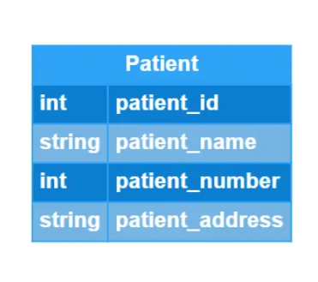

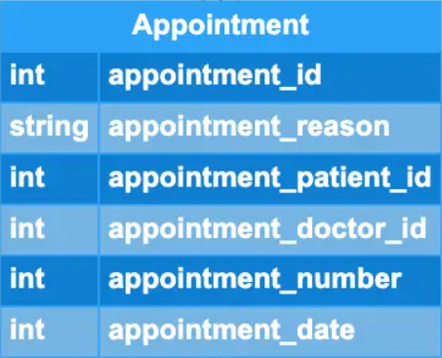

Fig.4.4 Patient schema. Fig.4.5 Appointment Schema.

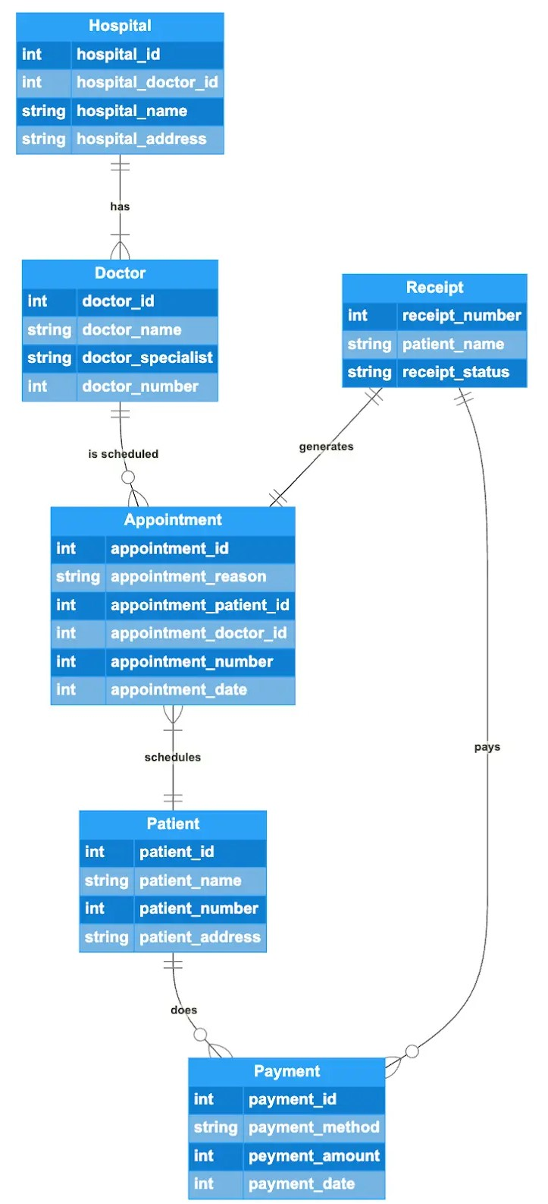

Fig 4.3: Full Schema of Hospital management System.

## CHAPTER 5

### **METHODOLOGY**

###### Description of the Project work

The main objective of the project is to know fundamental concepts and can work on Agile methodology and Web Development, to gain a broad understanding build cycles.

The project flows as users create multiple projects in Jenkins to fetch the code, build, prepare data in database, run the automation tests, and deploy the code webserver.

To accomplish this, we have worked on the activities and tasks like Requirement analysis, User Story creation, and Story board on Trello, Write automation tests in Cypress, create projects in Jenkins.

**Table 5.1: Task and activity Table**

* + 1. **Waterfall Method**

1. **Requirements Gathering:** Work closely with hospital staff, administrators, and IT experts to understand their needs. This includes identifying the specific functionalities required such as patient management, staff management, billing, inventory, etc.
2. **System Design:** Create a detailed plan including the architecture of the system, database structure, user interfaces for different roles (doctors, nurses, administrators, etc.), and how different modules will interact.
3. **Implementation:** Develop the system according to the design specifications. This involves coding, creating databases, and building the interfaces.
4. **Testing:** Perform various tests to ensure that the system works as intended. This includes unit testing of individual components, integration testing to check how different modules work together, and system testing to validate the system as a whole.
5. **Deployment:** Once testing is successful, deploy the system in the hospital environment. Train the staff on how to use it effectively.
6. **Maintenance:** Provide ongoing support, address issues, and incorporate updates or enhancements as needed based on user feedback and changing requirements.
   * 1. **Align method**

|  |  |  |  |
| --- | --- | --- | --- |
| **S.No.** | **MODULE**  **NAME** | **APPLICABLE**  **ROLES** | **DESCRIPTION** |
| 1. | LOGIN | PATIENT DOCTOR ADMIN | **PATIENT:** Can login using unique Id and Password after this system shall show his/her profile.  **DOCTOR:** Can login using unique Id and Password after this system shall show his/her profile.  **ADMIN:** Can login using unique Id and Password after this system shall show a  profile with links to maintain the website. |
| 2. | REGISTRATION | PATIENT | **PATIENT:** Can Register by filling all the required details, after this the system will verify the details and check if already  registered or not. |
| 3. | MAKE APPT. | PATIENT | **PATIENT:** Can Select doctor, date time and make an appointment request after this system shall show a confirmation for  appointment request. |
| 4. | CANCL APPT. | PATIENT DOCTOR | **PATIENT :** Can Cancel appointment if want to by just one click after this system shall ask for re-schedule or refund of payment.  **DOCTOR :** Can Cancel appointment if want to by just one click after this system shall  send a message to the patient. |
| 5. | PAYMENT | PATIENT | **PATIENT :** Enter payment details and make payment after this system shall show the  generated bill by the hospital. |
| 6. | DOCTOR MODULE | ADMIN | **ADMIN :** Can add a new doctor by filling all the details after this system shall show a confirmation message.  Can Remove a doctor by just one click after this system shall show confirmation  message. |

## CHAPTER 6

### **RESULTS AND DISCUSSIONS**

##### 6.1 SNAPSHOTS

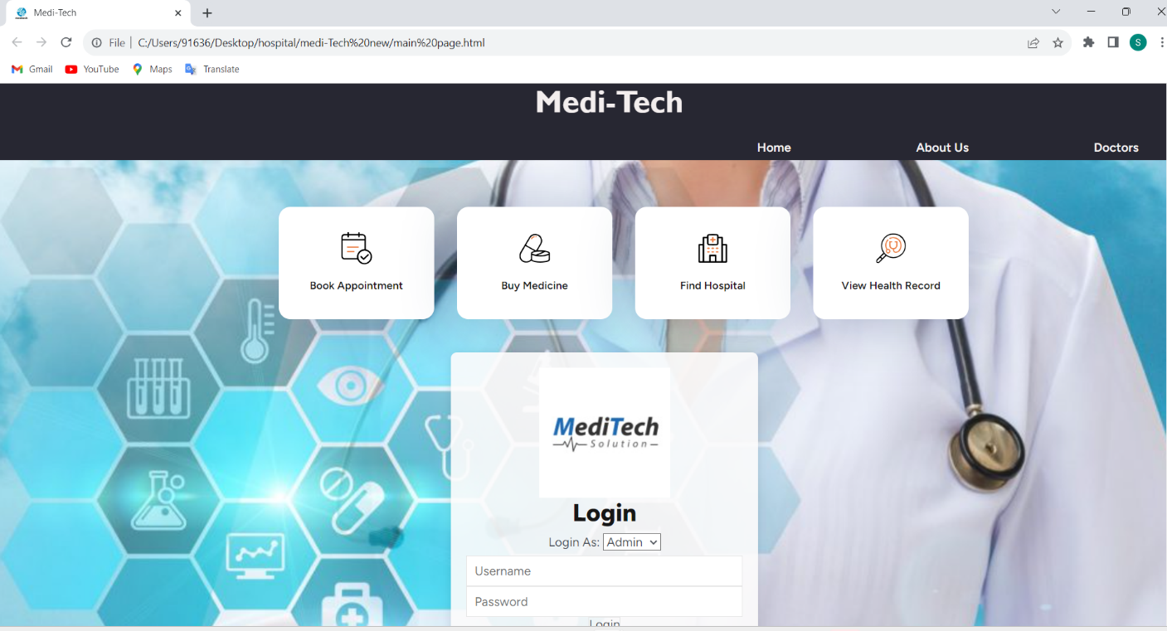

Fig 6.1: Medi-Tech Dash Board.

The Figure 6.1 shows the free style projects executed on Medi-Tech.

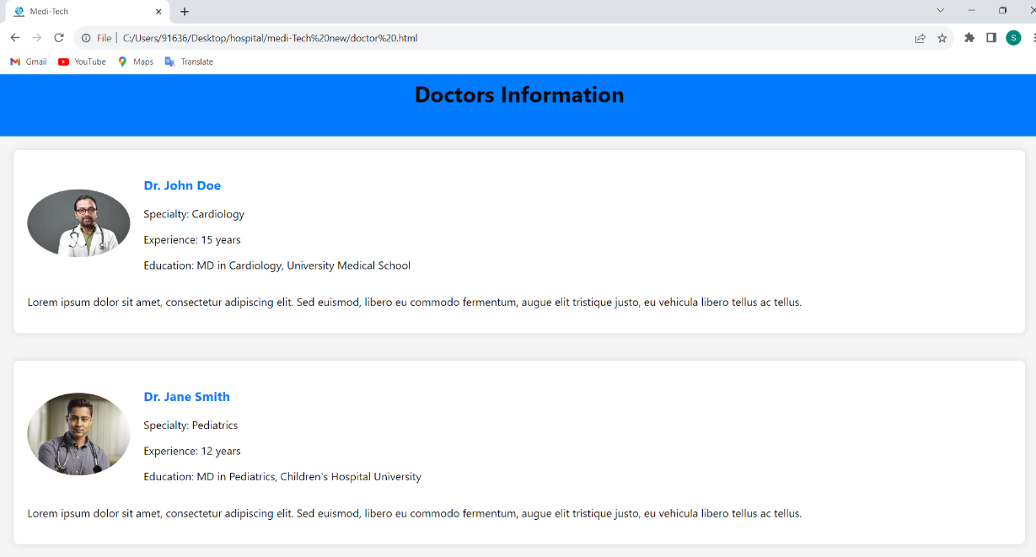

Fig 6.2: Doctor Details.

The Figure 6.2 shows that Doctors Details in Medi-Tech.

Fig 6.3:Medi-Tech About.

The Figure 6.3 shows About page in Medi-Tech

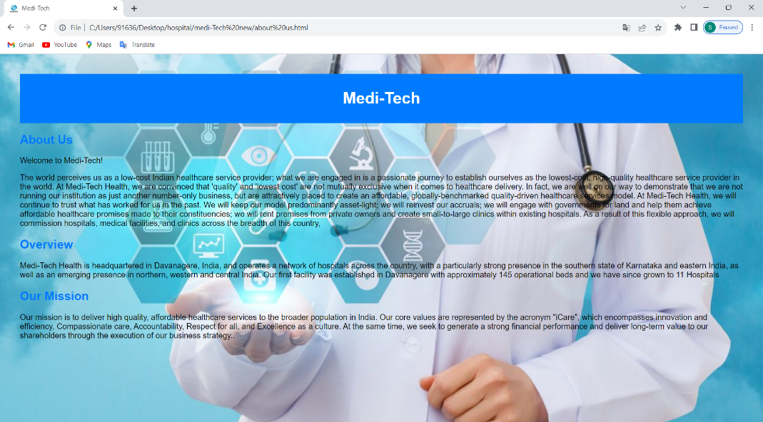

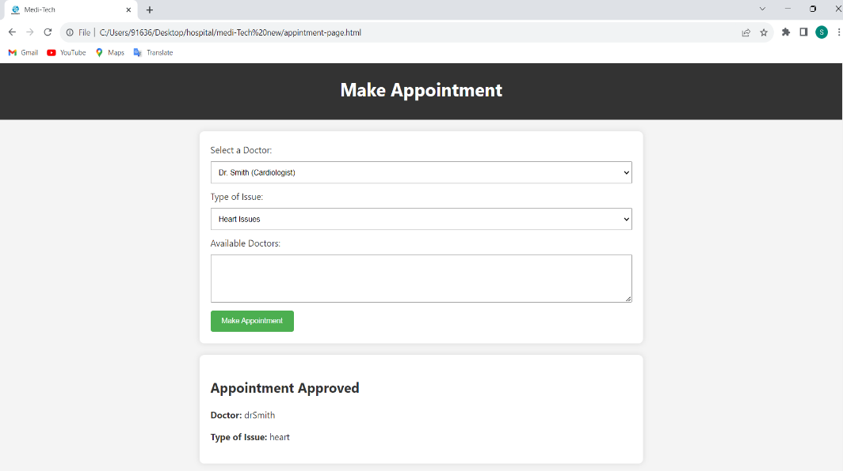

Fig 6.4: Medi-Tech Booking Appointments.

The Figure 6.4 how to book appointment in Medi-Tech is shown

|  |  |  |  |  |
| --- | --- | --- | --- | --- |
| **Table Name** | **Max rows** | **size of each row in bytes** | **No of tables** | **total size required in table in bytes** |
| Admin | 5 | 60 | 1 | 300 |
| Patient | 30 | 15 | 1 | 450 |
| New register | 6 | 190 | 8 | 54720 |
| Find Hospital | 100 | 140 | 1 | 14000 |
| Records | 6 | 190 | 100 | 114000 |
| Buy Medicines | 100 | 150 | 1 | 15000 |
|  |  |  | **Total** | 198470 |

Fig 6.5: Database size estimation for EC2

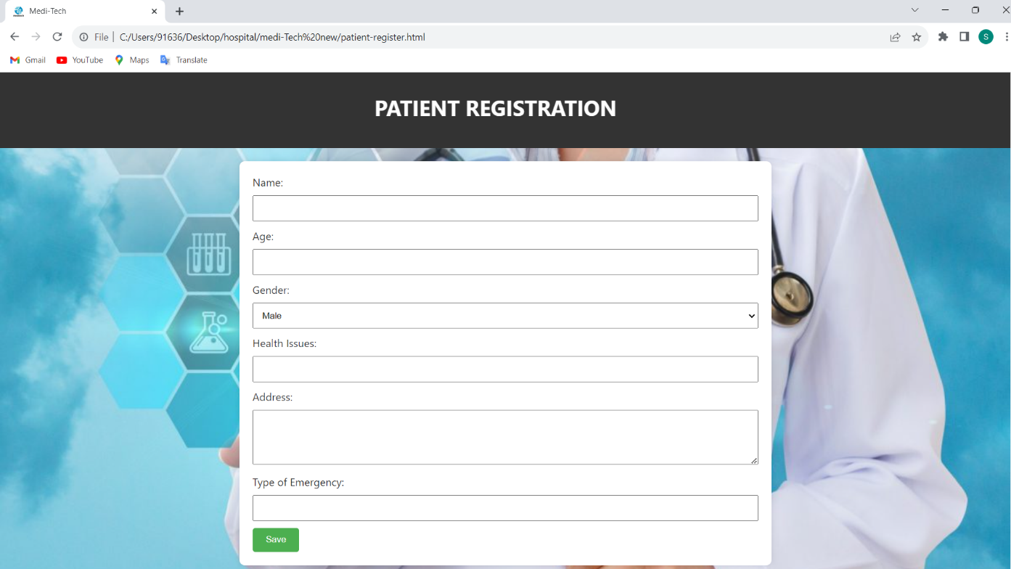

**The figure 6.4 Medi-tech new Registrations.**

Fig 6.6: Medi-Tech hospitals locations.

The Figure 6.6 showing physical locations to Medi-Tech Hospitals.

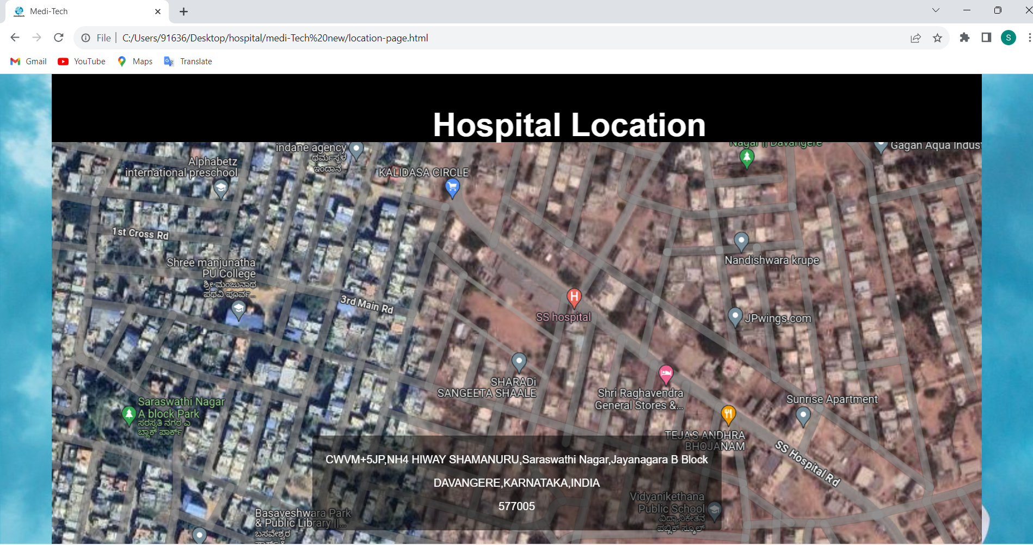

Fig 6.6: Apache and MySQL server.

The Figure 6.6 showing initialization of apache and mysql server using xampp.

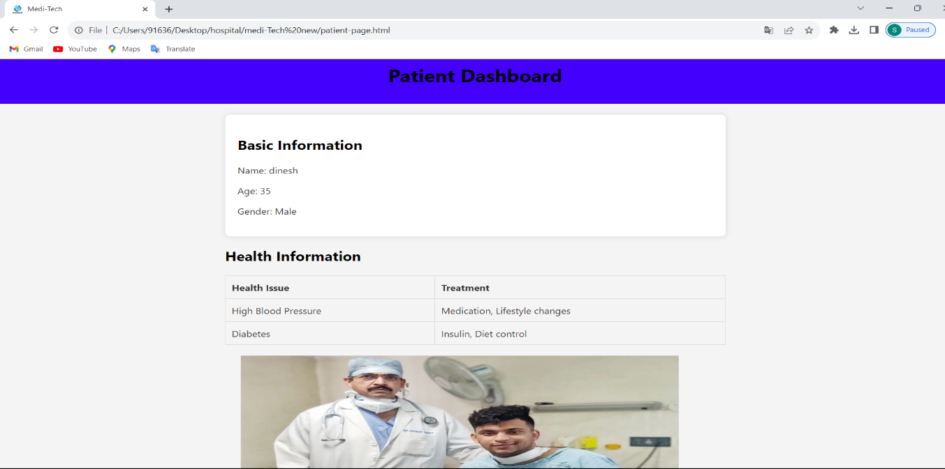

Fig 6.7: Medi-Tech Patient Dashboard.

The Figure 6.7 showing Patient dashboard in medi-Tech.

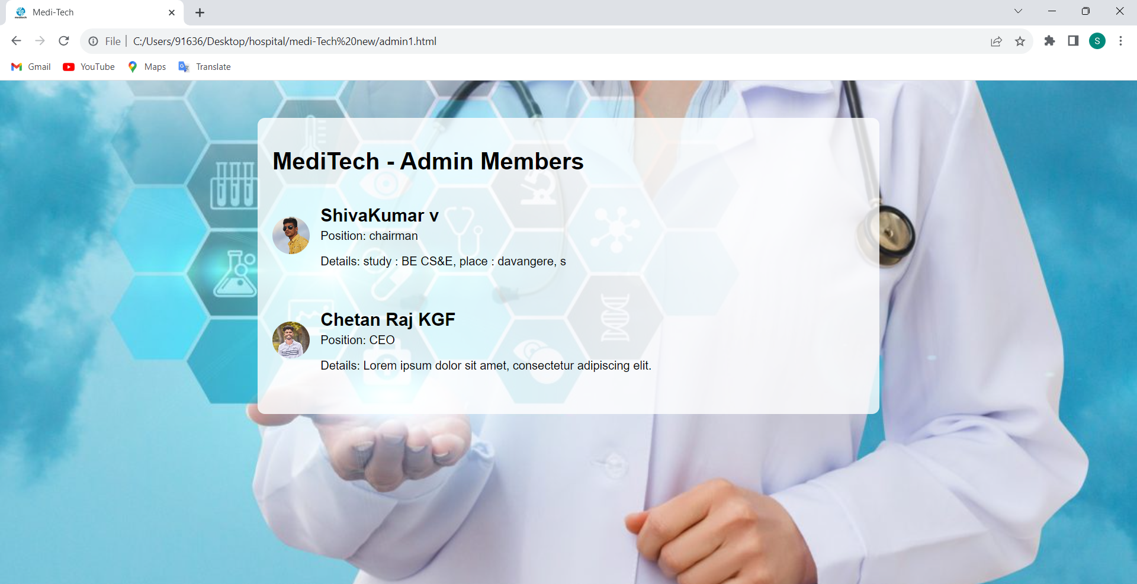

Fig 6.8: Medi-Tech Administration.

The figure 6.7 showing the Administrators of Medi-Tech Hospital.

## CONCLUSION

The activities on Agile methodology, Wed Development concepts and Backend, Logics have been learnt and demonstrated. By considering a case study of a “ Hospital Management System” project, the Agile process, Full Stack Web Development workflow have been implemented.

The detailed understanding of concepts on Front and Backend has made. Working with Logical concepts on a case study has given a deep insight from the Servlet server service perspective. Mysql facilitated distributed DATABASE, it enabled us to work on different parts of our project Individually.

Hospital management system is essential for maintaining detail about the Doctor, Patient, Admin etc. We understand that by using of Hospital management System project the work because very easy and we save lot of time .Hospital administrators would be able to significantly improve the operational control and thus streamline operations. Collecting and retrieving patient information ,accounting sometimes becomes awfully pathetic and complex. This product will eliminate any such complexity.

## REFERENCES

###### Links:

* <https://www.w3schools.com/html/default.asp>
* <https://stackoverflow.com/>
* https://www.w3schools.com/mysql/default.asp

###### Text books:

### **HTML and CSS: Design and Build Websites, by Jon Duckett**

* [Murach’s Java Servlets and JSP, 3rd Edition](http://www.amazon.com/Murachs-Java-Servlets-Edition-Murach/dp/1890774782?tag=javamysqlanta-20)
* Learning MySQL: Get a Handle on Your Data” by Vinicius Grippa and Sergey Kuzmichev, O’Reilly Media